***TABLEAU CAPSTONE***

***CYCLIST BIKE SHARE ANALYSIS***

**Process**

* *We received the capstone project of Cyclist bike share analysis.*
* *In this capstone, we need to understand how casual riders and annual members use cyclist bikes differently.*
* *We have been provided the data set which contains information of the riders who are all casual / annual membership riders, who are all using electric and docked bikes and time frame of the riders*
* *From the given datasets, we need to clean the data by removing errored and unwanted details of the riders.*
* *With the help of cleaned data, we need to analyze and provide the key insights to the business with help of Tableau visualization*

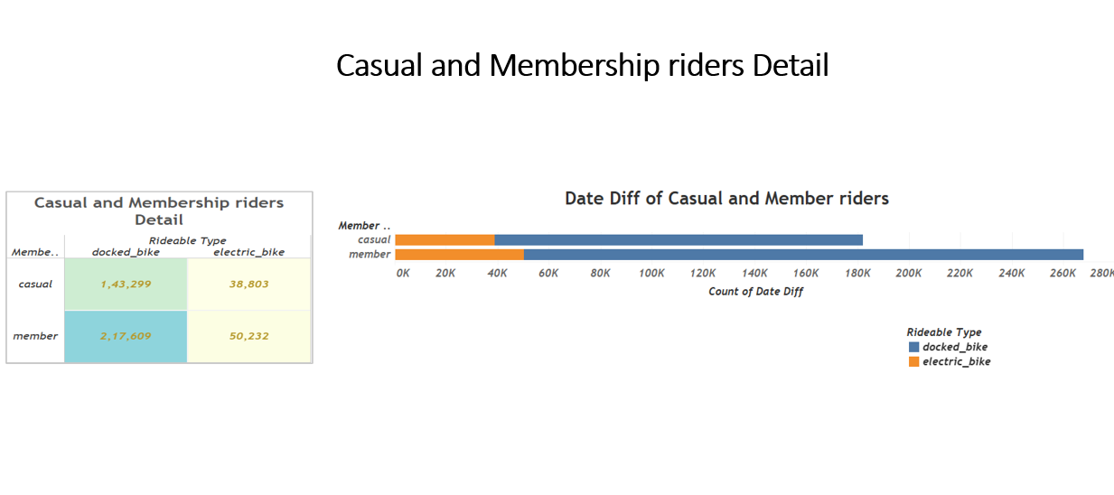

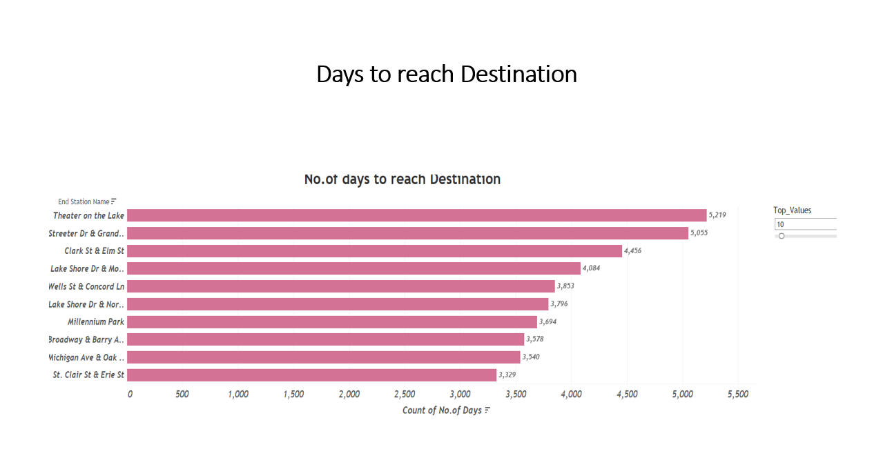

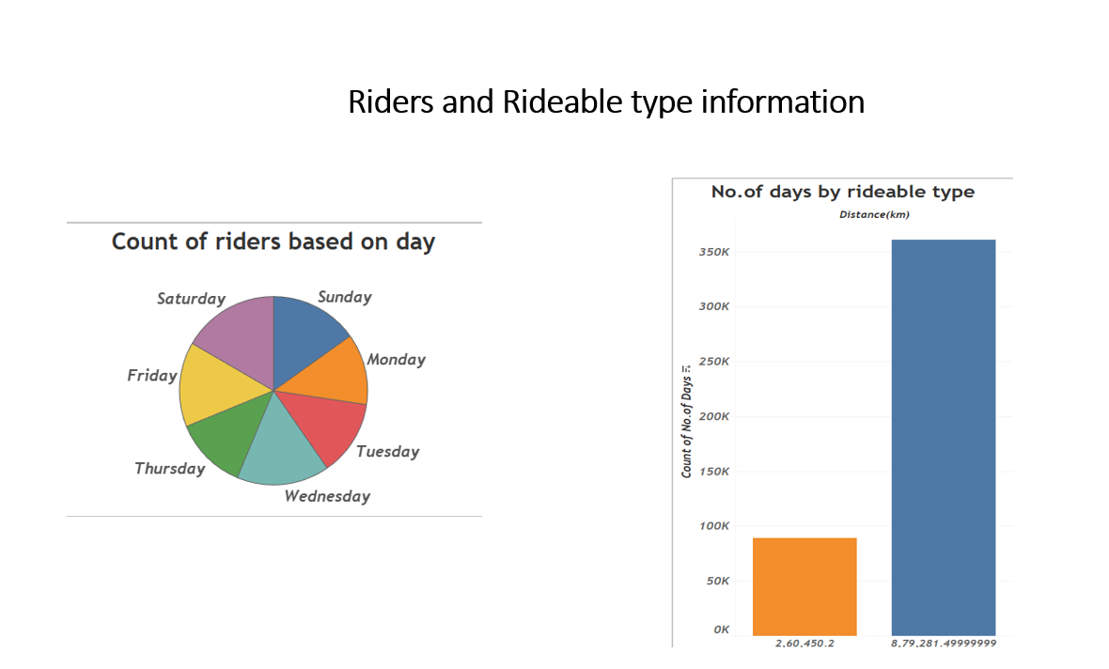

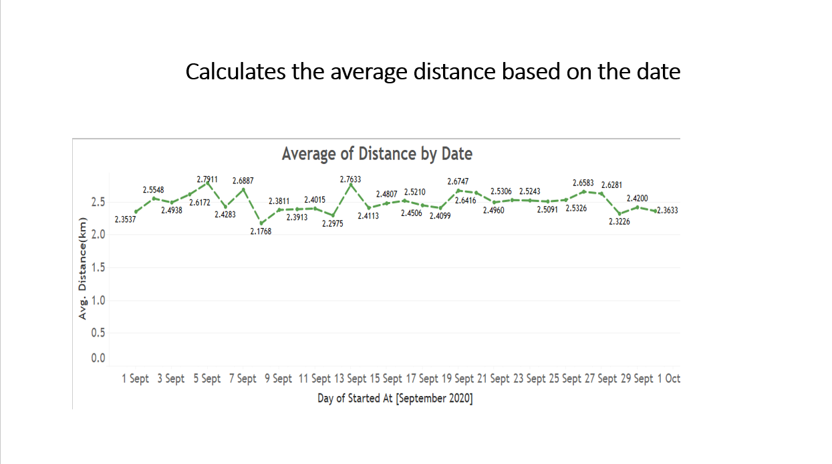

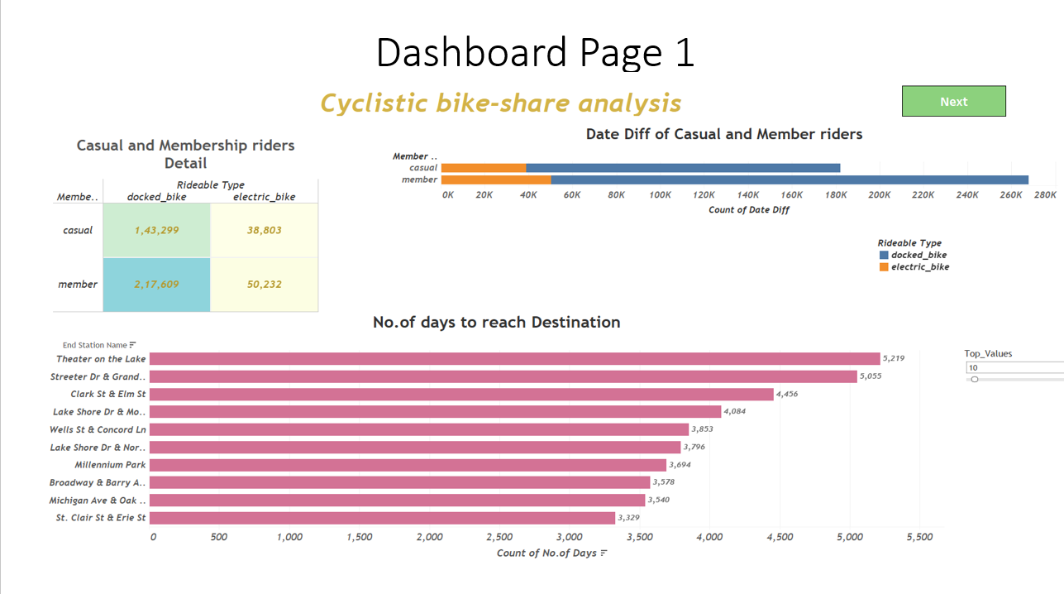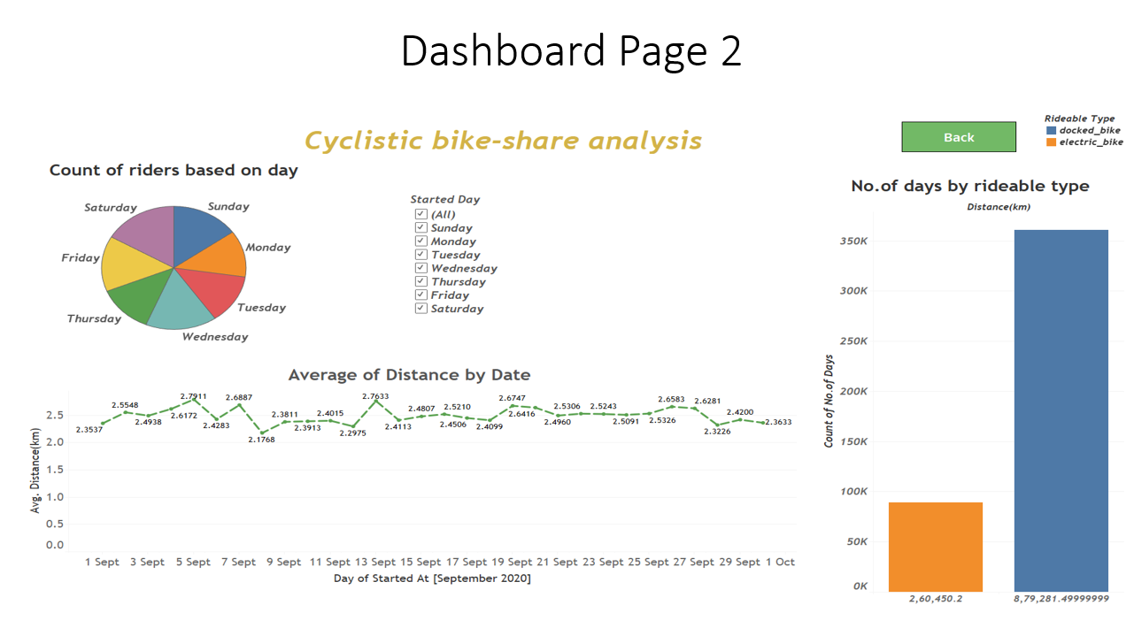

**END**